**Team Members:**

Roshini Varada- 26

V H N V R S Sai Pavan -27

**Introduction:**

To create a S3 storage bucket in AWS and host a static page

**Objective**

To host a sample static application in S3 bucket.

**Prerequisites:**

To create an account in AWS

**Steps to create a bucket in AWS:**

Create an Account in AWS, fill the details and proceed by accepting the agreement.

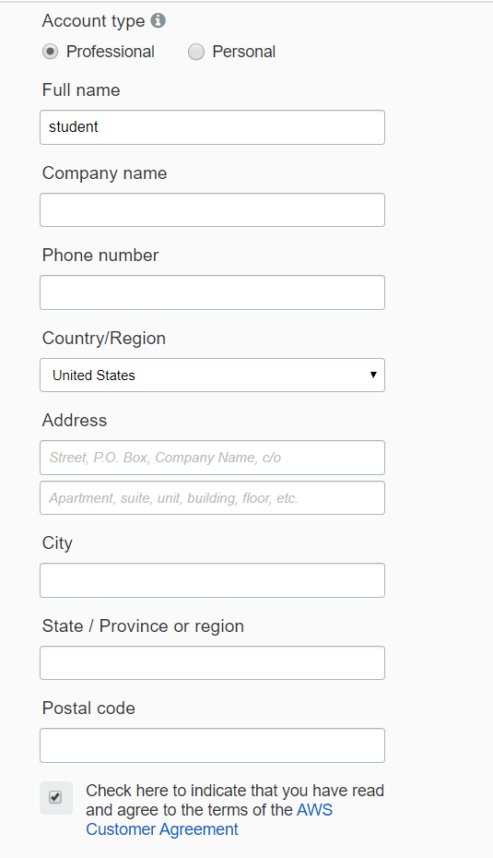

After that proceed further by paying 1 dollar and get the account approved.

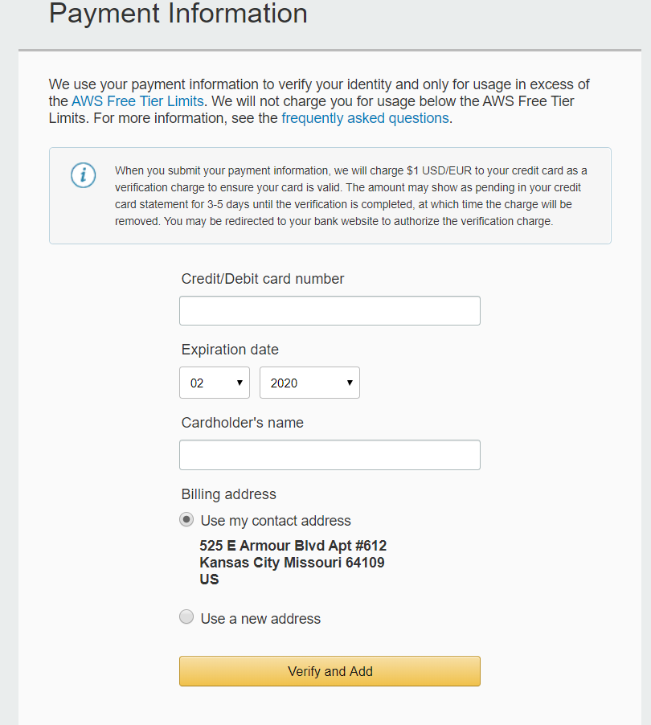

After the confirmation of the account, log in into the account and sign into AWS console.

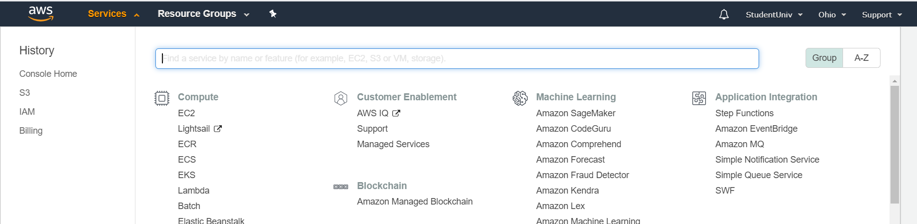

Under the services select the S3 service.

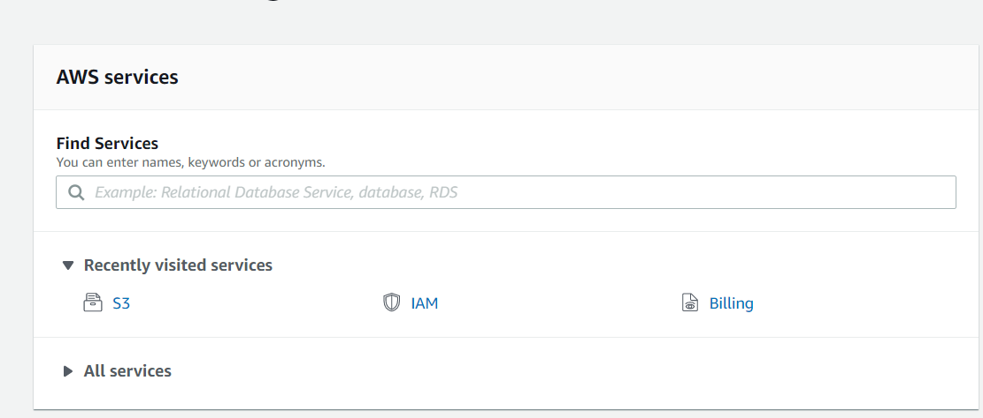

Click create bucket to the s3 bucket.

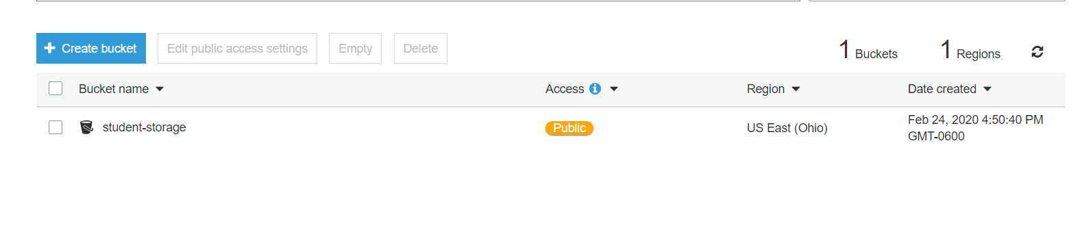

Give the name of the bucket and click next and click next in the configure options without changes

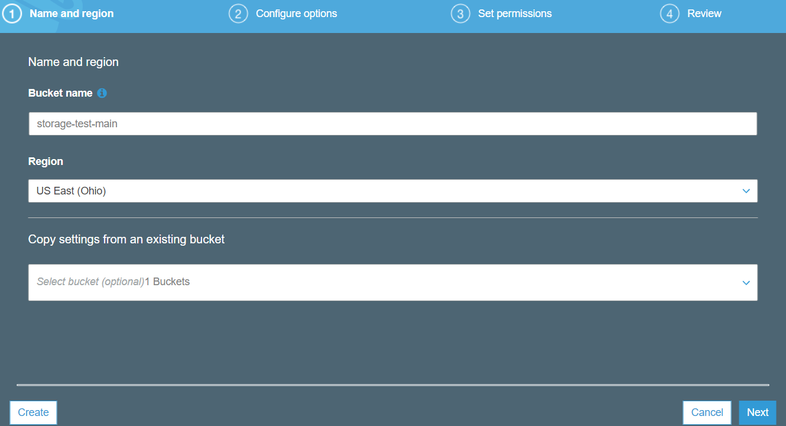

Disable the block public access button in order to provide the public access.

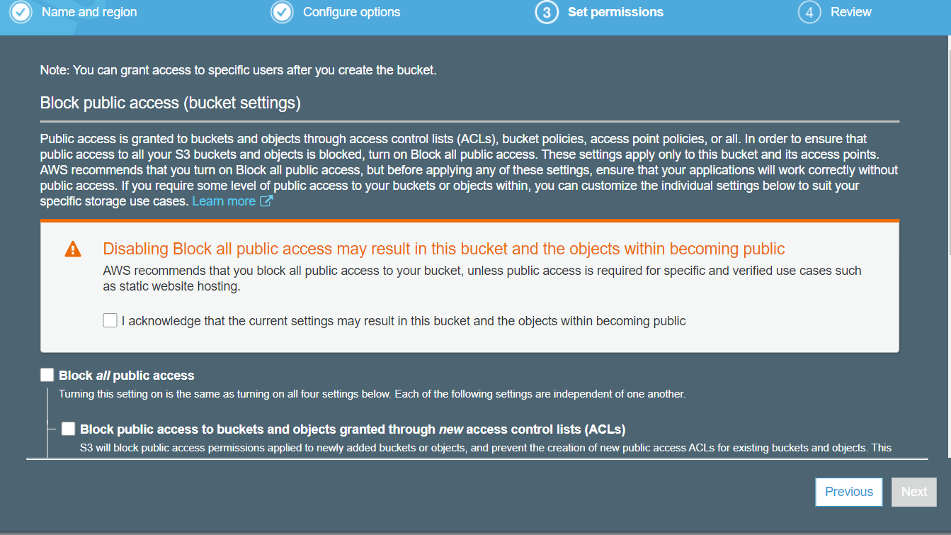

Go to bucket policy and update the policy changes

{

"Version": "2012-10-17",

"Statement": [

{

"Sid": "AddPerm",

"Effect": "Allow",

"Principal": "*",

"Action": "s3:GetObject",

"Resource": "arn:aws:s3:::**BUCKET-NAME**/*"

}

]

}

Go to properties on clicking the s3 bucket and select the static web hosting

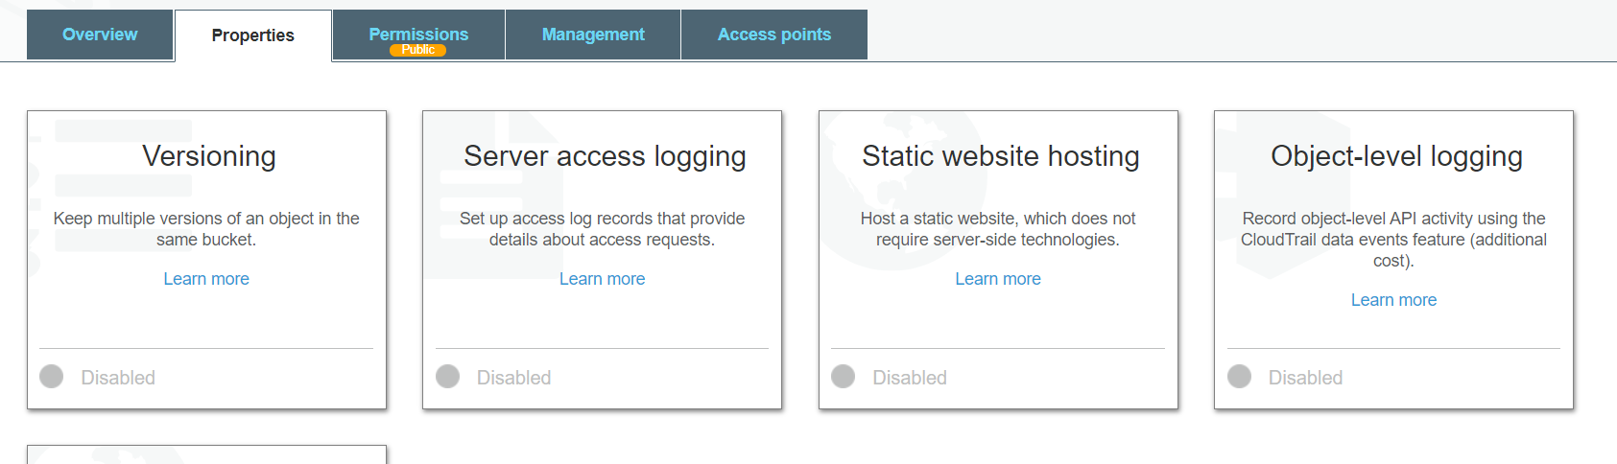

Select the static website hosting and update the document name here

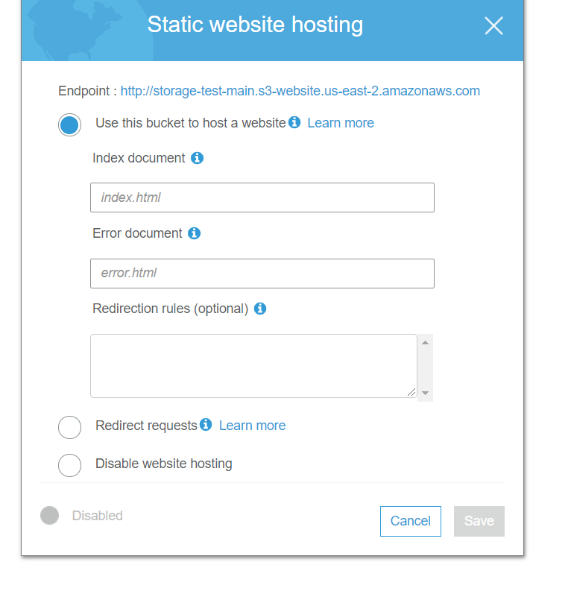

Click the upload option in the overview page and select a file to upload

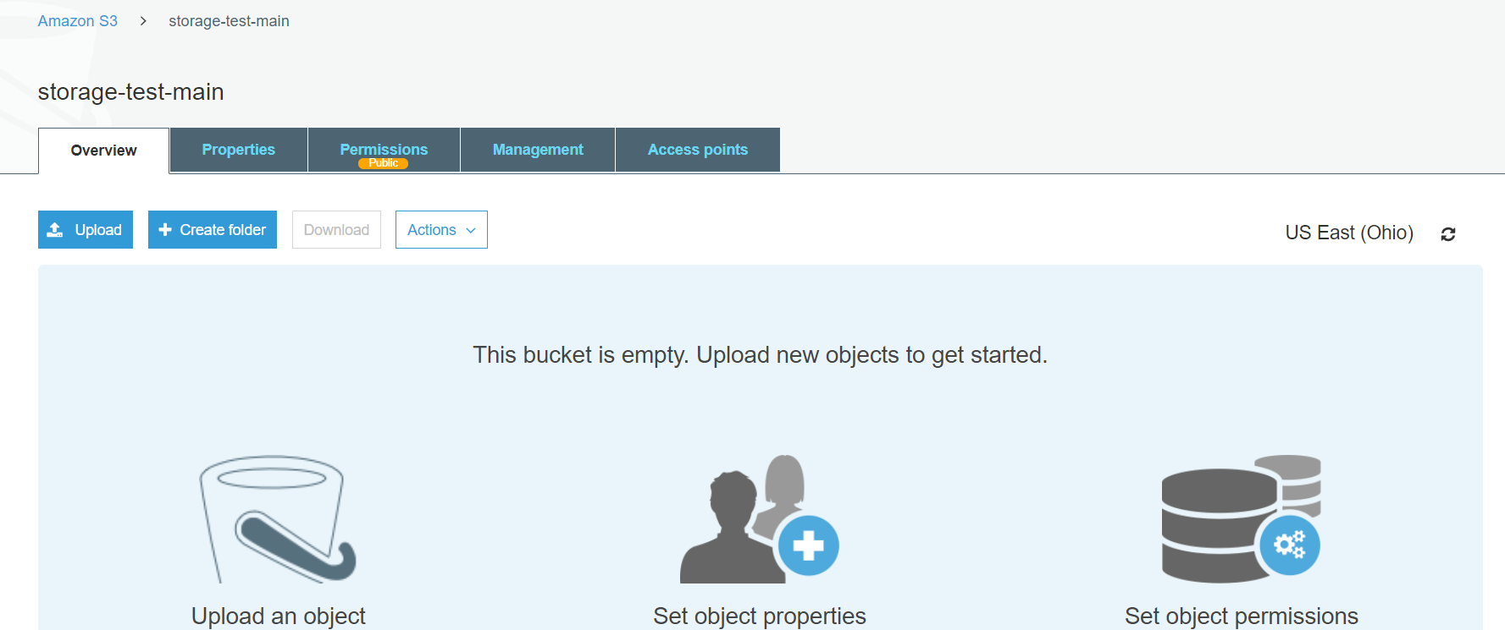

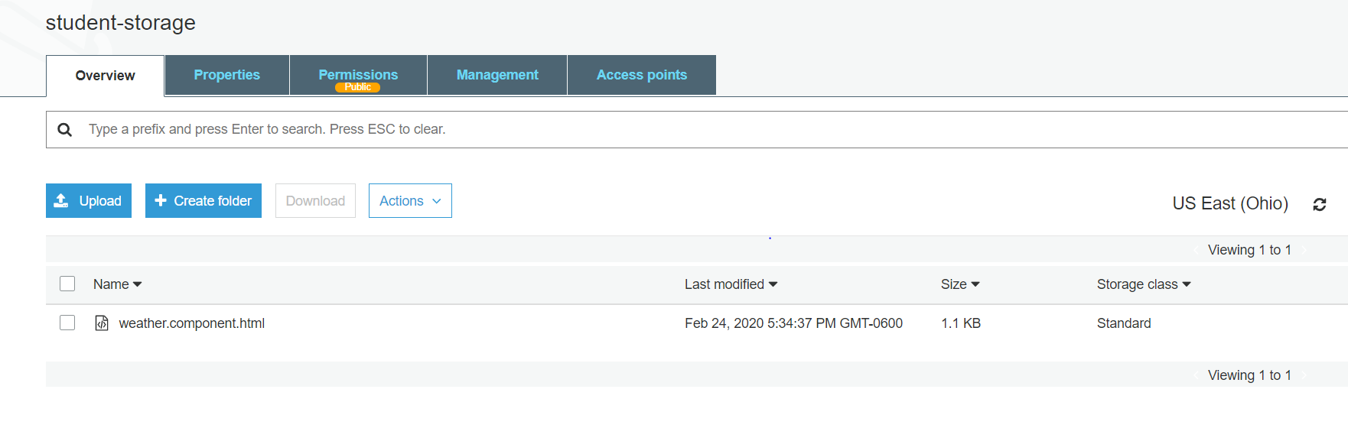

Provide the details in the hosting website properties.

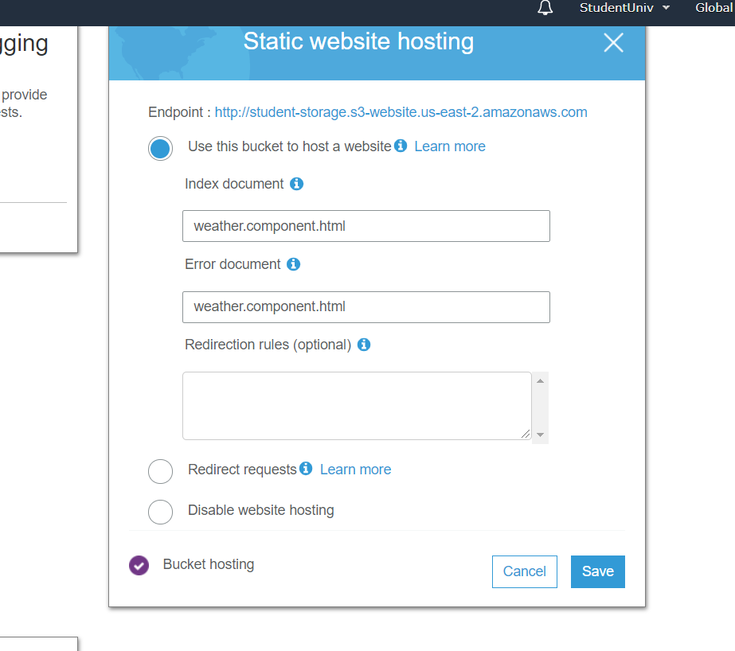

Click on the end point to see the static page

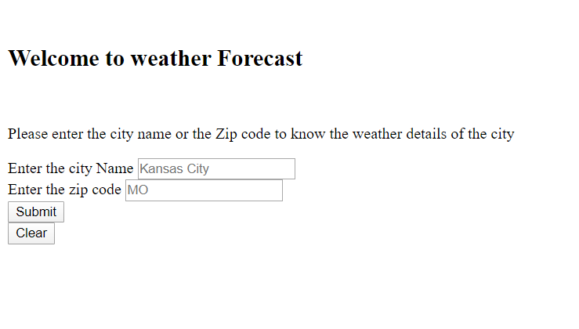

**Limitations:**

Aws account charges for every API hit. Hence it involves huge money in the large-scale projects.

**Conclusion:**

From this experiment we will be able to know to know how to host a static webpage in the S3 bucket.

**YouTubeLink:**

https://youtu.be/P0NcSDvkTsU

**References:**

<https://dev.to/samueldaviddelacruz/how-to-host-your-static-web-app-on-aws-s3-in-10-steps-3kgp>